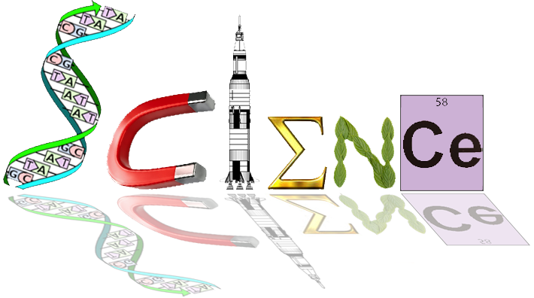

**12 ATAR Human Biology**

**ATHBY Task 5:**

Homeostasis Test

**Weighting 3%**

**Time: 60 minutes**

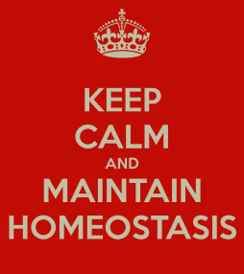

Multiple Choice: 20 marks

Short Answer: 35 marks

Extended Answer: 10 marks

**TOTAL 65 MARKS**

**Multiple Choice Section (20 marks)**

**Answer All Questions**

1 Homeostasis is the process that keeps the internal environment constant. As this is a complex process, models to explain how it works have been developed for different

aspects of the internal environment. One such model is the ‘stimulus-response

feedback’ model.

Which of the following shows the components of the ‘stimulus-response feedback’ model in the correct sequence?

a) stimulus, receptor, modulator, effector, response, feedback

b) stimulus, effector, modulator, receptor, response, feedback

c) stimulus, receptor, effector, modulator, response, feedback

d) stimulus, effector, receptor, modulator, response, feedback

2 In a stimulus response feedback loop model, the environmental signal that alerts us is best described as the:

a) receptor

b) effector

c) response

1. stimulus

3. Receptors involved in regulating our body temperature are called

a) photoreceptors because light is associated with heat

b) chemoreceptors

c) thermoreceptors

d) mechanoreceptors

4. Antidiuretic hormone is involved with which homeostatic mechanism?

a) body fluid composition

b) body temperature

c) blood sugar

d) blood pressure

5. Dr Smith is giving a series of lectures on homeostatic mechanisms found in the body that control certain outcomes. He has received a note from one of his students with four possibilities regarding the hormone and the process by which glucose molecules are chemically combined in long chains to form glycogen molecules. Which one is correct?

a) insulin and glucogenesis

b) insulin and glycogenolysis

c) insulin and gluconeogenesis

d) insulin and glycogenesis

Question 6 refers to the graph below



6 Antidiuretic hormone is important in controlling water balance. The graph shows

changes in the concentration of antidiuretic hormone as plasma solute concentration

changes.

The change in antidiuretic hormone in the blood plasma at 285 mOs/kg was due to

a) an increase in osmotic pressure in the cells.

b) a decrease in the solute concentration of the plasma.

c) an increased intake of water into the cells.

d) a decrease in blood pressure in the plasma.

7 Aldosterone is a hormone found in the **adrenal medulla** which acts on the **liver** to increase the amount of sodium. The statement would be correct if some or all of the words in bold were replaced with these words:

a) adrenal cortex and kidney

b) kidney and decrease

c) adrenal cortex, kidney, decrease and potassium

d) adrenal cortex, kidney and decrease

8 Which of the following statements concerning the control of blood gases is correct.

a) the carbon dioxide concentration produces the most immediate effect  
b) the carotid and aortic bodies respond rapidly to the blood oxygen concentration.  
c) hydrogen ion receptors are found only in the carotid artery  
d) a more rapid rate of breathing is produced when the hydrogen ion concentration

increases.

9 In the control of blood pressure, which of the following is correct.  
  
a) in response to low blood pressure, sympathetic nerves from the cardiovascular

regulating centre of the medulla increase cardiac output.

b) in response to high blood pressure, cardiac output increases with a decrease in stroke volume and heart rate.

c) in response to low blood pressure, parasympathetic nerves from the cardiovascular

regulating centre cause vasodilation

d) in response to low blood pressure, nerve impulse from pressoreceptors in the medulla increase.

10 After a meal of fish and chips with lots of salt which of the following would be true.  
  
a) More sodium would be present in the urine  
b) the secretion of aldosterone from the adrenal cortex would decrease.  
c) the secretion of adrenalin from the adrenal cortex would decrease  
d) both a and b above.

11 Negative feedback is where :  
  
a) the stimulus affects the response to reduce the response.  
b) the response affects the stimulus to reduce the stimulus  
c) the stimulus affects the response to increase the stimulus.  
d) the response is independent of the stimulus.

12 Homeostasis is   
  
a) the maintenance of a constant internal environment for the efficient functioning of

cells.  
b) the regulation of the composition of body fluids.  
c) the maintenance of a stable internal environment for the optimal functioning of cells.  
d) a regulated control of cell needs to provide for cellular respiration.

13 After a series of deep inhalations and exhalations (i.e. forced breathing) there is a period of reduced breathing rate because the:

a) The nitrogen concentration of the blood has increased

b) CO2 concentration of the blood has increased

c) CO2 concentration of the blood has decreased

d) O2 concentration of the blood has decreased.

14 After running hundreds of metres an athlete continues to breathe hard for some minutes because

a) the high level of oxygen in the blood stimulates the cardiovascular centre to

increase the breathing rate

b) the low level of bicarbonate ions in the blood stimulates receptors in the carotid and

aortic bodies to increase the breathing rate  
c) the high level of carbon dioxide in the blood stimulates the receptors in the medulla increase the breathing rate   
d) he needs to lower down the body temperature because of the excess heat

15 Which of the following is correct about the role of insulin, it…  
  
a) Stimulates cells to changes glucose to glycogen  
b) Stimulates cells to changes glycogen to glucose  
c) Slows down the oxidation of glucose by tissue cells  
d) Slows down the change of fats and proteins to glucose.

16 If a drug completely destroyed the cells of a man’s pancreas, we would expect to

find a  
  
a) high concentration of glucose in his blood and in his urine  
b) normal concentration of glucose in his blood and a high concentration in his urine  
c) high concentration of glucose in his blood, but low concentration in his urine  
d) low concentration of glucose in both blood and urine.

**Question 17 refers to information below**

Occasionally an individual is born without sweat glands. Such a person and a normal individual were placed in cool dry conditions and the skin and mouth temperatures recorded. The two persons were then placed in a moist hot environment and further recordings made. The results were as follows:

|  |  |  |  |  |
| --- | --- | --- | --- | --- |
|  | Skin temperature | Oral temperature | loss of H2O from  skin and lungs | Urine Volume |
| Cool Dry Atmosphere  Person X  Person Y | 33.9oC  32.7oC | 36.9oC  36.9oC | 5g  5g | Not recorded  Not recorded |
| Hot moist atmosphere  Person X  Person Y | 40.0oC  37.6oC | 38.6oC  37.0oC | 22 gm  262 gm | 270 ml  10 ml |

17 Select the correct statement from below.  
  
a) person X was born with sweat glands  
b) person Y was born without sweat glands  
c) person X was born without sweat glands   
d) person Y had more urine volume due to the presence of sweating.

18 When glucose molecules are chemically combined in long chains to form glycogen

the process is known as

a) gluconeogenesis

b) glycogenolysis

c) respiration

d) glycogenesis

19 Shivering is an effective means of combating cold because

1. the rapid sequence of weak muscle contractions results in chemical energy being converted to heat energy.
2. it promotes piloerection which traps a layer of air next to the skin.
3. it causes vasoconstriction, which greatly reduces heat loss from the skin.
4. it makes people engage in voluntary exercise and this warms the body.

20 Which of the following describe the mechanism responsible for preventing the lungs from over-inflating?

1. the stimulation of chemoreceptors in the respiratory centre.

b) the stimulation of stretch receptors in the lungs.

c) a build up of carbon dioxide in the bloodstream.

d) the release of a hormone into the bloodstream

**Short Answer: (35 marks)**

**Answer All Questions**

1. (a) Name the labelled parts A, B, C, D, E, of the nephron below. (6 marks)

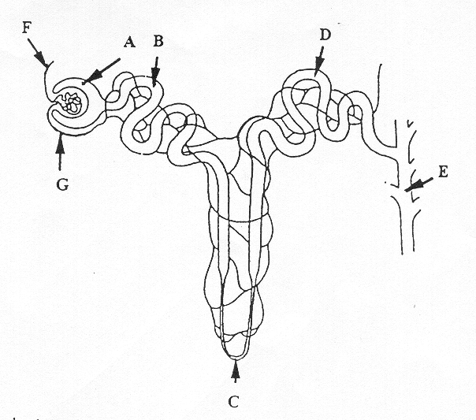

|  |  |
| --- | --- |
| **A** | Glomerular capsule/bowman’s capsule |
| **B** | Proximal convoluted tubule |
| **C** | Loop of Henle |
| **D** | Distal convoluted tubule |
| **E** | Collecting duct |
| **G** | Efferent arteriole |

(b) Where does filtration occur, selective re-absorption and tubular secretion occur.

(3 marks)

Filtration between glomerular capsule and glomerulus

Selective reabsorption proximal convoluted tubule

Secretion distal convoluted tubule

1. What hormone can affect this process?

Antidiuretic Hormone (1 mark)

**Total 10 marks**

2. The following questions refer to the graph below

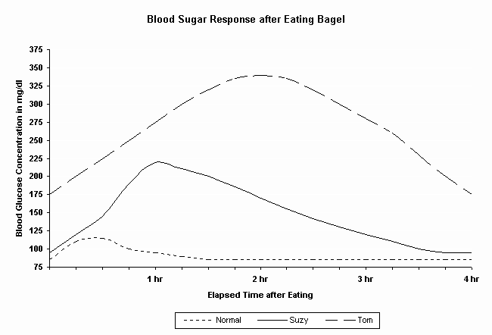

(a) Describe what happened to blood glucose concentration following the consumption of a bagel. (1 mark)

Increase in glucose concentration

(b) Which hormone would be secreted during this time?

Insulin (1 mark)

(c) Describe how this hormone would achieve such an effect. (2 marks)

Any 2 of

Insulin stimulates:

Increase uptake of glucose by body cells

Liver and muscle cells to take up glucose and synthesise glycogen

Adipose cells to take up glucose and store as fat

All actions decrease blood glucose levels.

(d) How long does it take for the “Normal” blood sugar levels to maintain homeostasis?

1.5 hours (1 mark)

(e) Both Suzy and Tom’s blood glucose concentrations are much higher than normal.

Suggest why this is so. (2 mark)

Tom could have type 1 diabetes and is not able to produce insulin. Blood sugar levels remain high

Suzy type II diabetes Cells ate less responsive to insulin Suzy removes glucose from the blood at a slower rate than the normal response

**Total 7 marks**

**Question 3 refers to the information below**

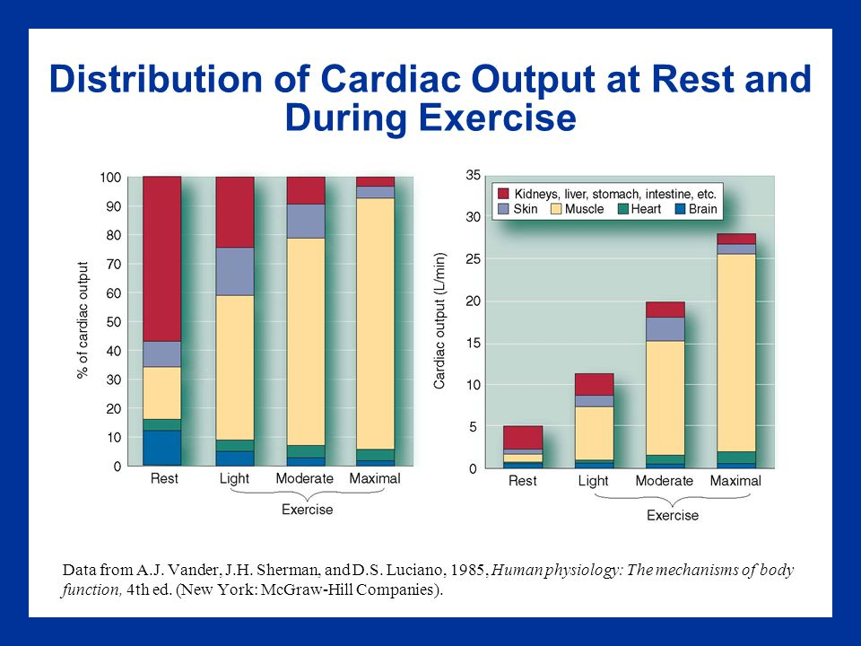

***Examine the graph below:***

3.a) What volume of blood flows to the gut and liver in 5 minutes when the body is at rest?

(1 mark)

3x5 = 15L ________________________________________________________________________

b) What is the percentage increase in blood flow to skeletal muscle between rest and

strenuous exercise? (1 mark)

88% muscles strenuous,

16% rest

70-73 % increase Any value between

________________________________________________________________________

c) Explain how the changed blood flow to the various organs between rest and

strenuous exercise is achieved (ie how is the blood redirected). (2 marks)

_sympathetic nervous system sends a message to the smooth muscle located in arterioles located in the digestive system causing arterioles to constrict and reduce blood flow to cut.(1)

arterioles serving skeletal muscles dilate due to **local chemical effects**. These occur within a muscle as a result of the muscle fibres using more energy. Local chemical factors can trigger vasodilation. Eg **increased carbon dioxide**, **increased hydrogen ion**. **(1)**

blood flow can increase up to 20 times as a muscle exercise

(d) Explain why there is increased blood flow to the skin during strenuous exercise.

(1 mark)

Increase heat production due to increase metabolic. Blood transport heat to skin –increase loss of heat via radiation and conduction.

**Total 5 marks**

***The diagram, below shows how the hypothalamus regulates the secretion of thyroid hormones. Use the diagram to help you complete the questions that follow.***

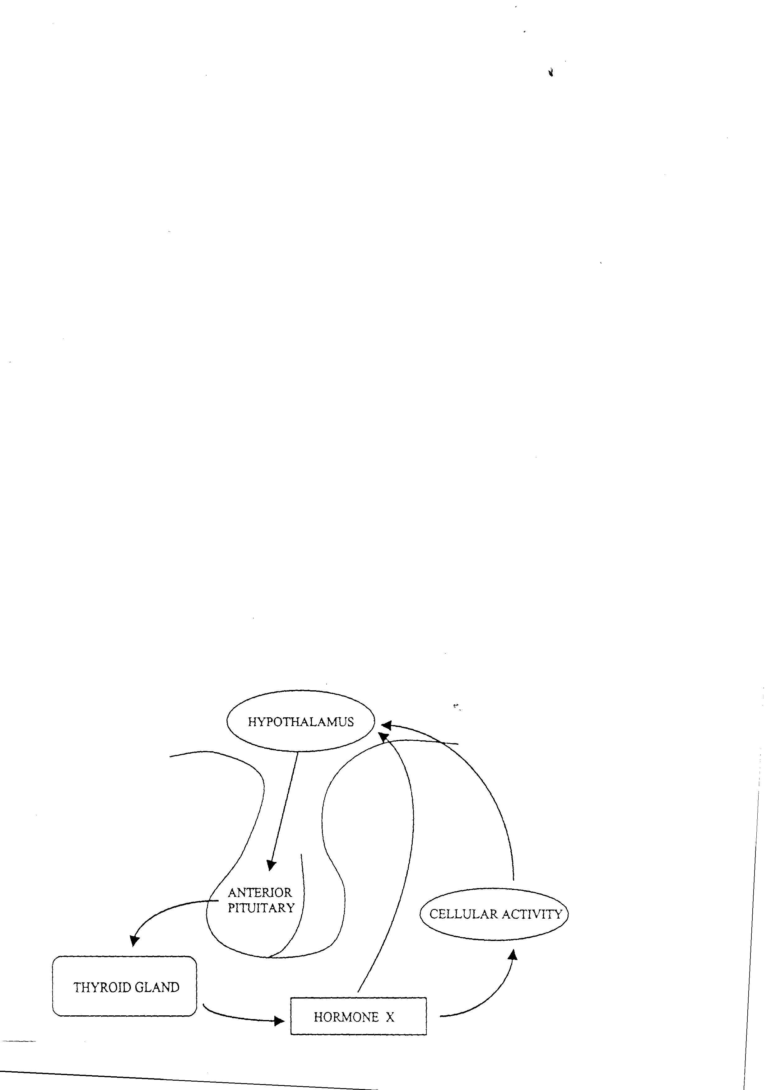

4. (a) Name two factors that stimulate the hypothalamus to initiate the control system.

1_ low levels of throxine

2 __decrease in core body temp ___________________________________________________________ (2 marks)

(b) The hypothalamus responds by secreting releasing factor thyroid stimulating hormone that acts on the anterior pituitary to cause it to secrete thyroid stimulating hormone (2 marks)

(c) What is the name of hormone X released from the thyroid gland?

thyroxine (1 mark)

(d) List two ways the body responds to the release of hormone X.

1__Increase metabolic rate

2 __Increase body temperature (2 marks)

**Total 7 marks**

5. (a) Explain why the cells of the body need to be maintained at a relatively steady

temperature of 370C.

(2 marks)

Optimal cell function

temp affects speed of chemical reaction due to kinetic energy of cells (1)

enzymes are temp specific and work efficiently at 37 chemical reaction slow down at lower temps or enzymes denature at temps above 40 (1)

(b) **List** the ways in which the body tends to gain and lose heat

(2 marks)

Radiation, convection, conduction (any 2)

(c) What behavioural changes can we make to lower our core body temperature?

(2 marks)

Any 2 reasonable response

egRemove extra clothing

**Total 6 marks**

**Extended Answer Section (10 marks)**

**Select one only**

1. The PCAWA Tetrathlon is a 4 phase event requiring athletes to run 3 kilometres, swim as far as they can in 5 minutes, shoot 5 shots at a target using a laser pistol and ride a 2km cross country. The event is always held in March and often temperatures are above 30oC. Competitors are encouraged to frequently drink water throughout the event.

With the aid of a fully labelled diagram explain the homeostatic process that would occur in the athlete’s bodies to ensure body fluids remain within the required tolerance limits to enable optimum function of the body cells.

* exercise and high ambient temp causes increase heat production and heat absorption
* body homeostatic response sweat glands increase sweating to cool body- results in high water loss (1)
* decrease water in blood- increase osmotic pressure of blood acts as a stimulus
* receptor osmoreceptors in hypothalamus
* modulator hypothalamus stimulates PLP to release ADH
* effector kidney, response increase permeability of distal convoluted tubules-increase water reabsorbed into capillaries
* feedback decrease osmotic pressure of blood ( 5)
* as this is occurring a thirst response is also taking place
* thirst centre in hypothalamus sends nerve impulse cerebrum/cerebral cortex
* conscious desire to drink
* effectors skeletal muscles, response drink
* reduce osmotic pressure (4)

**YEAR 12 ATAR HUMAN BIOLOGY**

Task 5: Homeostasis

SCORES:

MC: /20

SA: /35

EA /10

TOTAL: /65

_______ %

**NAME:_____________________________**

**TEACHER:__________________________**

**DATE:______________________________**

**Section A: Multiple choice (30 Marks)**

Answer all questions by circling the most correct answer on the multiple choice answer sheet.

1. a b c d 18. a b c d

2. a b c d 19. a b c d

3. a b c d 20. a b c d

4. a b c d

5. a b c d

6. a b c d

7. a b c d

8. a b c d

9. a b c d

10. a b c d

11. a b c d

12. a b c d

13. a b c d

14. a b c d

15. a b c d

16 a b c d

17 a b c d